Decision Support Tool (DST)

Software Version 1.0.09

User Guide



July 2019

Department of Veterans Affairs

Office of Information and Technology (OI&T)

Revision History

NOTE: The revision history cycle begins once changes or enhancements are requested after the document has been baselined.

|  |  |  |  |
| --- | --- | --- | --- |
| Date | Revision | Description | Author |
| 07/16/2019 | 3.1 | Software Version 1.0.09  Added note regarding the Average Drive Time and Average Wait Time not showing up for Clinical Services that require a manual entry. | AbleVets |
| 05/30/2019 | 3.0 | Software Version 1.0.04   * Updated name from National Service Desk to Enterprise Service Desk. * Updated the Facility Name description to include the radius for Specialty Care and Primary Care. | AbleVets |
| 05/21/2019 | 2.0 | GMRC*3*129   * Updated VA Facility search radius to 100 miles. * Updated DST dashboard screens. | AbleVets |
| 04/10/2019 | 1.0 | Initial Documentation Release for DST v1.0.03. | AbleVets |

**Artifact Rationale**

Per the Veteran-focused Integrated Process (VIP) Guide, the User’s Guide is required to be completed prior to Critical Decision Point #2 (CD2), with the expectation that it will be updated as needed. A User Guide is a technical communication document intended to give assistance to people using a particular system, such as VistA end users. It is usually written by a technical writer, although it can also be written by programmers, product or project managers, or other technical staff. Most user guides contain both a written guide and the associated images. In the case of computer applications, it is usual to include screenshots of the human-machine interfaces, and hardware manuals often include clear, simplified diagrams. The language used is matched to the intended audience, with jargon kept to a minimum or explained thoroughly. The User Guide is a mandatory, build-level document, and should be updated to reflect the contents of the most recently deployed build. The sections documented herein are required if applicable to your product.

Table of Contents

1. Introduction 1

1.1. Purpose 1

1.2. Document Orientation 1

1.2.1. Organization of the Manual 2

1.2.2. Assumptions 2

1.2.3. Coordination 2

1.2.4. Disclaimers 2

1.2.4.1. Software Disclaimer 2

1.2.4.2. Documentation Disclaimer 3

1.2.5. Documentation Conventions 3

1.2.6. References and Resources 3

1.3. Enterprise Service Desk and Organizational Contacts 3

2. System Summary 4

2.1. System Configuration 4

2.2. Data Flows 5

2.3. User Access Levels 5

2.4. Continuity of Operation 5

3. Getting Started 5

3.1. Logging On 5

3.2. System Menu 6

3.3. Exit System 9

4. Using the Software 11

4.1. Launching DST 11

4.1.1. Launching DST from an Unsigned Consult or When Ordering a New Consult 11

4.1.2. Launching DST from Add Comments to Consult 15

4.2. Capturing Provider and Veteran Decision Data 19

5. Troubleshooting 23

5.1. Unable to Lookup Clinical Service 23

5.2. MVI Error Handling 24

5.3. ES Error Handling 25

5.4. PPMS Error Handling 26

6. Acronyms and Abbreviations 27

List of Figures

Figure 1: CCAD DST Business Process workflow – Unsigned Order Consult 4

Figure 2: CCAD DST Business Process workflow – Signed Order Consult 4

Figure 3: CCAD DST Data Flow Diagram 5

Figure 4: DST SSOi Login Screen (VA) 6

Figure 5: DST Dashboard 6

Figure 6: Best Medical Interest of Veteran Menu Options 8

Figure 7: DST Logout 9

Figure 8: Order a Consult 12

Figure 9: MISSION Act Support Message 12

Figure 10: MISSION Act Requires DST Message 13

Figure 11: VA Single Sign-On 13

Figure 12: Select a Certificate 14

Figure 13: ActivClient Login 14

Figure 14: DST Dashboard Screen 15

Figure 15: Add Comment to Consult Dialog Box 16

Figure 16: Consult Toolbox Menu 16

Figure 17: VA Single Sign-On 17

Figure 18: Select a Certificate 17

Figure 19: ActivClient Login 18

Figure 20: DST Dashboard Screen 18

Figure 21: DST Save Success Message 19

Figure 22: Unable to Save Message 20

Figure 23: DST Save Failed Error Message 20

Figure 24: Link DST Data 20

Figure 25: DST Data 21

Figure 26: DST Data Displayed in Consult Details 22

Figure 27: Manual selection of Clinical Service 23

Figure 28: Veteran Identity Error Handling 24

Figure 29: Veteran Eligibility Error Handling 25

Figure 30: VA Facilities Error Handling 26

# Introduction

The Veterans Health Administration (VHA) Office of Community Care has a need for a real-time decision support tool to help VA Providers and Veterans quickly review the criteria proscribed in the VA Mission Act of 2018, determine whether a given Veteran is eligible and would be best served utilizing the Veterans Community Care Program, and document the decision rationale in the Veteran’s health record.

The DST software will:

* Allow the care provider to view relevant data within the existing CPRS consult order workflow, that helps the Veteran and VA provider decide if a consult service should be referred to the local VA facility, a near-by VA facility via Inter-Facility Consults (IFC), or to a community provider by providing information about the following:
* Drive time standards associated with the Standardized Episodes of Care (SEOC) related to the requested consult service.
* Average wait times for in-house/IFC consults within the drive time standards of the Veteran’s place of residence.
* Veteran’s eligibility for accessing care in the community and their stated preferences (opt-in/out)
* Allow the provider to select the consult decision and enter additional justification text when indicated.
* Based on the decision outcome, provide required information to the Electronic Medical Record (EMR) in order to initiate either an in-house, IFC, or Veteran Community Care Program (VCCP) consult order.
* Document the rational for the referral decision in the consult record.
* Generate structured text based on the displayed results that can be used for downstream report generation.

## Purpose

The purpose of this document is to provide instruction for utilizing the Decision Support Tool (DST) to standardize and streamline consult management for Community Care.

## Document Orientation

The *Decision Support Tool User Guide* will provide explanations of each screen and of all user interface options within the context of an easy to understand demonstration data scenario.

This document is also designed to provide the user with screen-by-screen “how to” information on the usage of Consult Toolbox.

### Organization of the Manual

**Section 1: Introduction**

The Introduction section provides the purpose of this manual, an overview of the DST software, an overview of the software used, project references, contact information for the user to seek additional information, and an acronyms and abbreviations list for this manual.

**Section 2: System Summary**

The System Summary section provides a graphical representation of the equipment, communication, and networks used by the system, user access levels, how the software will be accessed, and contingencies and alternative modes of operation.

**Section 3: Getting Started**

Information for the Getting Started section provides a general walk-through of the system from initiation through exit, enabling the user to understand the sequence and flow of the system.

**Section 4: Using the Software**

This section gives the user the “how to” information to use DST, including many step-by-step procedures.

**Section 5: Troubleshooting**

This section provides troubleshooting for the DST user.

**Section 6: Acronyms and Abbreviations**

This section provides a list of acronyms and abbreviations found in this document.

### Assumptions

This guide was written with the following assumed experience/skills of the audience:

* User has login credentials for CPRS.
* User has basic knowledge of the CPRS operating system (such as the use of commands, menu options, and navigation tools).
* User has Google Chrome installed on their machine.

### Coordination

N/A

### Disclaimers

#### Software Disclaimer

This software was developed at the Department of Veterans Affairs (VA) by employees of the Federal Government in the course of their official duties. Pursuant to title 17 Section 105 of the United States Code this software is not subject to copyright protection and is in the public domain. VA assumes no responsibility whatsoever for its use by other parties, and makes no guarantees, expressed or implied, about its quality, reliability, or any other characteristic. We would appreciate acknowledgement if the software is used. This software can be redistributed and/or modified freely provided that any derivative works bear some notice that they are derived from it, and any modified versions bear some notice that they have been modified.

#### Documentation Disclaimer

The appearance of external hyperlink references in this manual does not constitute endorsement by the Department of Veterans Affairs (VA) of this Web site or the information, products, or services contained therein. The VA does not exercise any editorial control over the information you may find at these locations. Such links are provided and are consistent with the stated purpose of the VA.

### Documentation Conventions

This manual uses several methods to highlight different aspects of the material.

Table 1. Documentation Symbols and Descriptions

|  |  |
| --- | --- |
| Symbol | Description |
| Triangle with an exclamation point (!) inside to indicate caution for the reader to take special notice of critical information. | **CAUTION:** Used to caution the reader to take special notice of critical information. |

1. Notes are used to inform the reader of general information including references to additional reading material.

### References and Resources

Readers who wish to learn more about DST, Consult Toolbox, and CPRS should consult the following:

* CPRS: Consult/Request Tracking in the VDL: <https://www.va.gov/vdl/application.asp?appid=62>

## Enterprise Service Desk and Organizational Contacts

For issues related to the CC DST that cannot be resolved by this manual or the site administrator, please contact the Enterprise Service Desk at 855-NSD-HELP (673-4357).

# System Summary

## System Configuration

Within the current CPRS order consult workflow, VA providers utilize the DST system to support the decision and election for consult services for a given consult.

Figure 1: CCAD DST Business Process workflow – Unsigned Order Consult

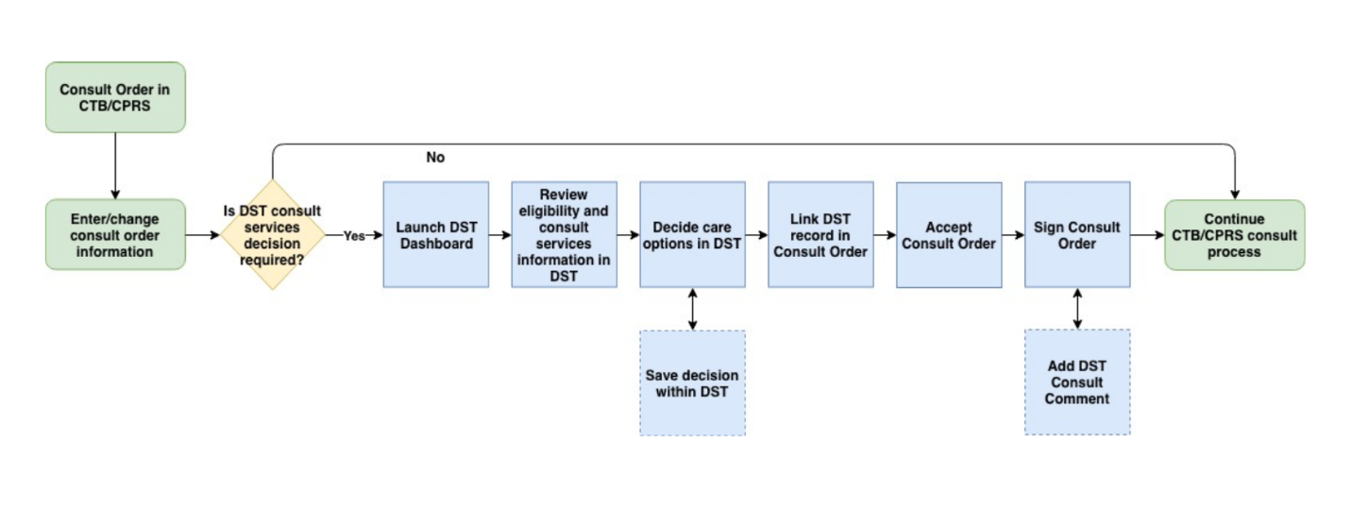

Figure 2: CCAD DST Business Process workflow – Signed Order Consult

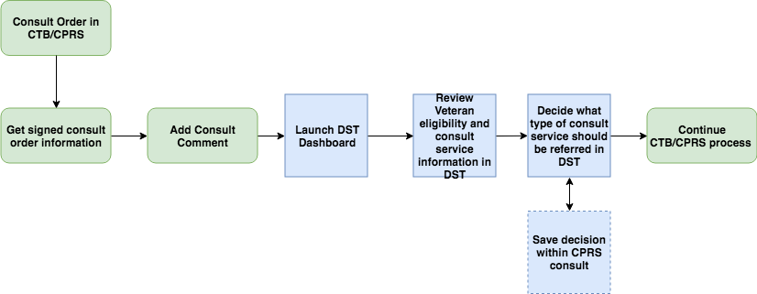

## Data Flows

Figure 3: CCAD DST Data Flow Diagram

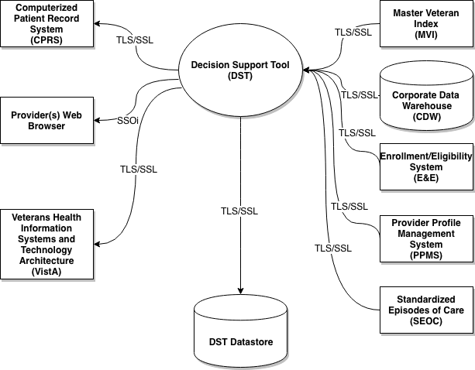

## User Access Levels

All VA providers will serve as the main user base for this system. The user must have access to CPRS to access DST.

## Continuity of Operation

DST falls under the VistA Continuity of Operations Plan.

# Getting Started

This section provides a general walkthrough of DST from initiation through exit.

## Logging On

The standard VA-provided Single Sign-On Integration (SSOi) page is displayed and the user must enter their Personal Identification Number (PIN) to load the DST Dashboard and access the remote data sources.

Figure 4: DST SSOi Login Screen (VA)

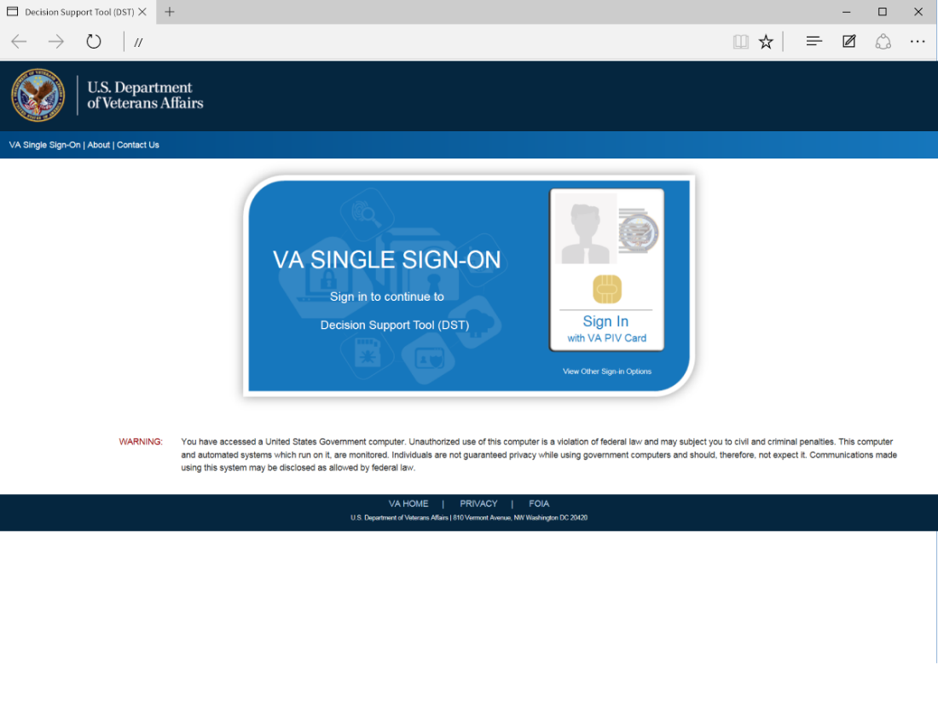

## System Menu

The DST Dashboard features three sections: **Consult**, **VA Facilities**, and **Community Care**.

Figure 5: DST Dashboard

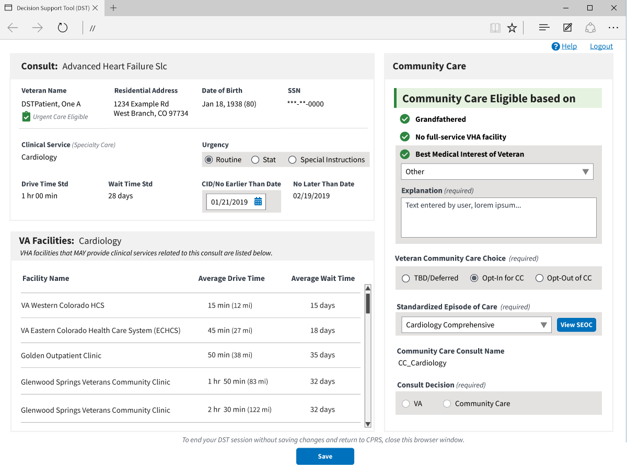

Following are descriptions of the features on the DST Dashboard.

* **Consult** section
* **Name** – Veteran name. This is a read only field supplied by CPRS.
* **Residential Address** – Veterans residential address. This is a read only field supplied by the MVI data interface. Provided by Eligibility & Enrollment System.
* **Date of Birth** – Veterans date of birth. This is a read only field supplied by CPRS.
* **SSN** – Veterans Social Security Number (SSN). This is a read only field supplied by CPRS.
* **Clinical Service** – Consult Clinical Service. Automatically assigned when the user launches DST from CPRS or this field can be manually entered, it depends if you are using an unsigned or signed consult.
* **Urgency** –
  + - **Routine** - Populated by user. A Routine consult indicates the patient should be seen in accordance with the clinically indicated date.
    - **Stat** - Populated by user. Stat consults will be defined as an “immediate” need. The sender of a stat consult is required to:
      * Contact the intended receiver of the consult request to discuss the patients’ situation.
      * Enter “Today” in the clinically indicated date/earliest appropriate date field of the consult.
      * Enter “Stat” in the urgency field of the consult.
      * A stat consult must be completed within 24 hours.
    - **Special Instructions** - Populated by user.
* **Drive Time Std** - This is a read only field supplied by local DST datastore.
* **Wait Time Std** - This is a read only field supplied by local DST datastore.
* **CID/No Earlier Than Date** – As instructed by provider.
* **No Later Than Date** – This field can be modified if the Urgency type **Special Instructions** option is selected.
* **VA Facilities** section: VHA facilities that MAY provide clinical services (Primary Care or Specialty Care) related to this consult are listed in this section. DST searches an internal table (updated nightly from CDW) to filter the returned list to facilities within a 100 mile radius that offer services associated with consult Clinical Service (based on the National IFC Dashboard).

1. Average Drive Time and Average Wait Time will not show up for Clinical Services that require a manual entry. The DST application attempts to map consult names to Clinical Services for all Nationwide sites. However, due to the distributed and dynamic nature of consult name addition by the local VA site, DST is not able to keep a real time list of these Consult to Clinical Service mappings. When DST application cannot find a Consult to Clinical Service mapping, the application requires that the user enter the Clinical Service manually on the DST dashboard. When this clinical service is entered, the DST application will continue to request and populate the facility drive time and average wait time based on Residential Address and the entered clinical service.

* **Facility Name** – List of VHA facilities that offer a related consult service within a 100-mile radius for Specialty Care and a 40-mile radius for Primary Care of the Veteran residential address (sorted by Average Drive Time low-to-high).
* **Average Drive Time** - This refers to the average time it takes to drive from the Veterans official residence as noted in the enrollment system, to the VA facility closest to the veteran that offers the service requested. This measurement uses our provider profile management system (PPMS) which is a Microsoft-based product that utilizes Bing maps and its algorithm to determine the time to travel between the two addresses as determined over the past 30 days of estimates taken at the particular time the DST is run.
* **Average Wait Time** – This is measured as the average time, based on a rolling 30-day assessment, of the time an appointment is created to the date of the appointment itself. This is the method used for the access to care public facing website but does not reflect the eligibility for Community Care. Community Care wait time eligibility is determined at the time of scheduling the appointment – NOT AT THE TIME OF REQUESTING IT.
* **Community Care** section: If DST receives a unique Veteran ICN back from MVI, it sends the ICN to the Enrollment System (ES) API to retrieve the Veteran’s residential address and a Veterans eligibility identifying string containing one or more of the following eligibility codes applicable to DST: “U” – Urgent care eligible, “G” – Grandfathered, “H” – Hardship, or “N” – No full-service VHA facility.
* **Best Medical Interest of Veteran** – Drop-down menu. There is a Community Care policy and procedure that allows a VA provider to request the ability for a Veteran to receive care in the community based on that Veterans best medical interest and this request must be approved by the Chief of Staff or their designee. Congress requests that VA providers consider: The nature or simplicity of the request to care, the need for an attendant, the frequency of the care, the timeliness of available appointments (VA or Community), and potential improvement in the continuity or quality of care.

Figure 6: Best Medical Interest of Veteran Menu Options

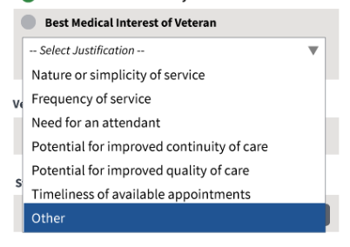

* + - **Nature or simplicity of service**
    - **Frequency of service**
    - **Need for an attendant**
    - **Potential for improved continuity of care**
    - **Potential for improved quality of care**
    - **Timeliness of available appointment**
    - **Other**
* **Explanation (required)** field – Displays only if **Other** is selected from the **Best Medical Interest of Veteran** drop-down menu.
* **Veteran Community Care Option (required)** -
  + - **TBD/Deferred** - When this radio button is selected it will require a SEOC to be selected if the Veteran ultimately opts in to Community Care. Because a SEOC is required on every consult that goes to Community Care, this allows the ordering provider to select the appropriate SEOC to match the consult/order that is being ordered at the time it is placed. Additionally, it allows the creator of the consult and thus user of the DST to use information even if the Veteran is a) Not ready to decide or b) Not present. This button then enables the provider to ask a team member to finish the opt in/out decision later while maintaining the integrity of the initial DST dashboard information.
    - **Opt-In** – Veteran elects care in the community.
    - **Opt-Out** – Veteran elects to remain within the VA for care.
* **Standardized Episode of Care (required)** – Relates to Clinical Service. A service or group of services the VA authorizes a community provider to perform to complete the consult order including the duration and number of visits that might be necessary. Some or all of the authorized services may need to be performed during any particular episode of care.
* **Consult Decision** -
  + - **VA**
    - **Community Care**

## Exit System

To exit DST, click **Logout** at the upper right corner of your screen.

Figure 7: DST Logout

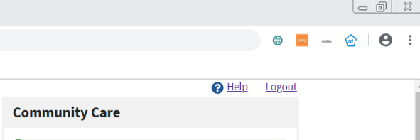

1. To end your DST session without saving changes and return to CPRS, close the browser window.

# Using the Software

## Launching DST

DST can be accessed the following ways:

* Accessing the Decision Support Tool Via an Unsigned Consult
* Accessing the Decision Support Tool when Ordering a New Consult
* Accessing the Decision Support Tool Via Adding a Comment in a Signed Consult

The sections below provide additional information regarding how to launch DST.

### Launching DST from an Unsigned Consult or When Ordering a New Consult

DST can be launched from the **Order a Consult** dialog box from an unsigned consult and when ordering a new consult. When the CPRS window titled **Order a Consult** is active and populated as an outpatient consult without a DST ID already in the Reason for Request, CTB displays a message over the **Accept Consult** button while it sends the Consult to Service/Specialty name to DST to determine if the consult is applicable to the MISSION Act.

DST searches an internal table (updated nightly from Corporate Data Warehouse (CDW)) to determine whether the Clinical Service associated with the consult requires DST and returns the result to CTB.

If DST returns FALSE, no action is initiated by CTB and the consult order workflow continues uninterrupted. If DST returns TRUE or a previous DST ID is found in the Reason for Request field, CTB displays a movable, non-modal window to inform the user that the consult should be reviewed for eligibility under the MISSION Act and allows them to open the DST prior to accepting the consult.

Figure 8: Order a Consult

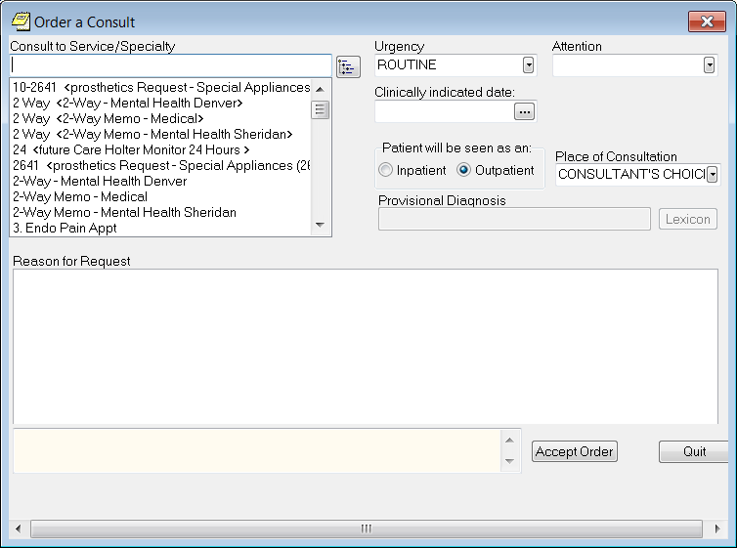

To launch Decision Support Tool (DST) from **Order a Consult**, follow the steps listed below:

1. From the **Order a Consult** window, select an option from the **Consult to Service/Specialty**. A message stating that it is checking to see if the consult requires MISSION Act support displays.

Figure 9: MISSION Act Support Message

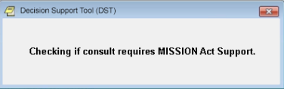

If MISSION Act requires the use of the DST, a message will display.

Figure 10: MISSION Act Requires DST Message

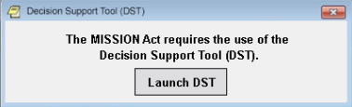

1. Click **Launch DST**. The **VA Single Sign-On** page displays.

Figure 11: VA Single Sign-On

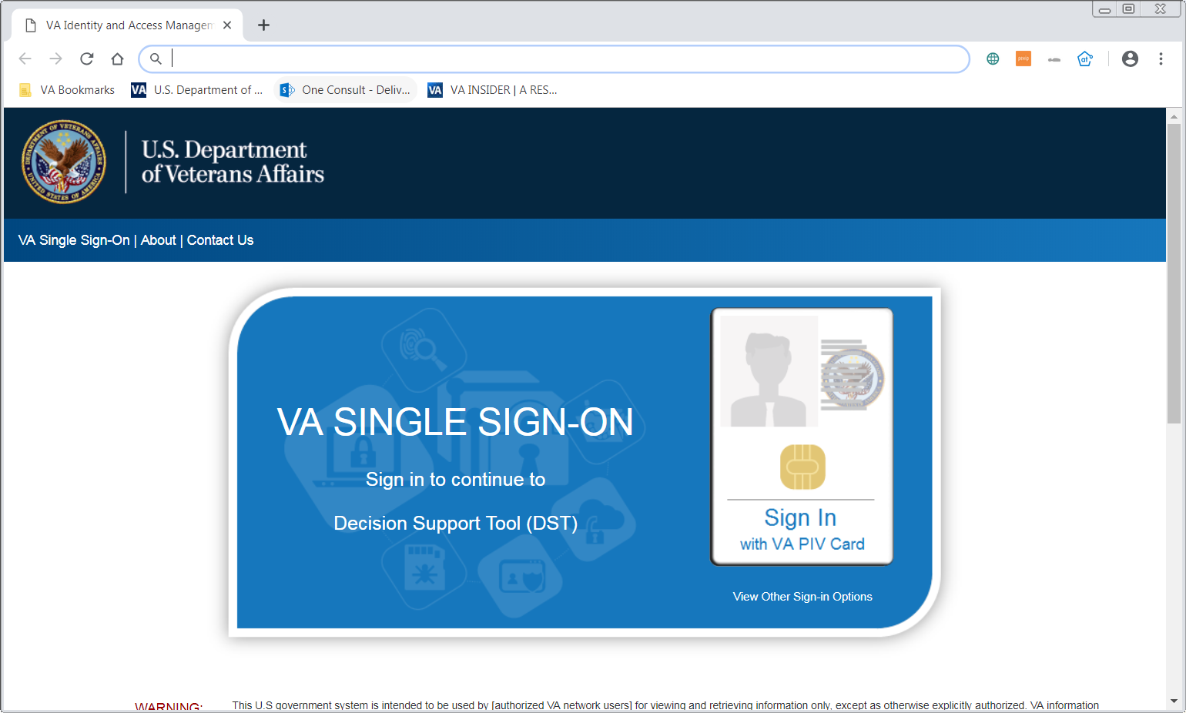

1. Click **Sign In with VA PIV Card**. The **Select a Certificate** dialog box displays.

Figure 12: Select a Certificate

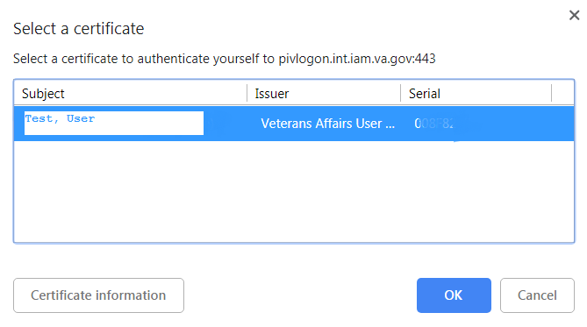

1. Select a certificate to authenticate yourself and click **OK**. The **ActivClient** dialog box displays.

Figure 13: ActivClient Login

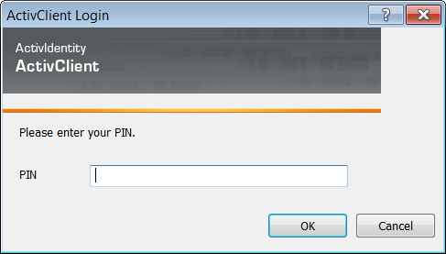

1. Enter your PIN and click **OK**. The DST Dashboard displays.

Figure 14: DST Dashboard Screen



### Launching DST from Add Comments to Consult

For a period of 30 days after a consult has been signed, DST can be accessed from the Consult Toolbox menu that is displayed when you right-click inside the Add Comment to Consult window in CPRS. When DST is launched this way, the user input data is carried-forward from the most recent DST data set if present.

1. DST Data is kept in the local database for a period of 30 days after the last update. The data is used to populate the consult comment when the order is signed and to restore the user entries when DST is reopened.  If someone opens DST from a consult after the DST data has been deleted, they will see the same as if DST was being opened for the first time on the consult.  Eligibility and facility information is always updated in real-time, while the Best Medical Interest of the Veteran, Veteran Community Care Option, SEOC, and Consult Decision will be blank.

To launch Decision Support Tool (DST) from CTB Add Comment to Consult, follow the steps listed below:

1. From the **Action** menu, select **Consult Tracking…** > **Add Comment**. The **Add Comment to Consult** window displays.

Figure 15: Add Comment to Consult Dialog Box

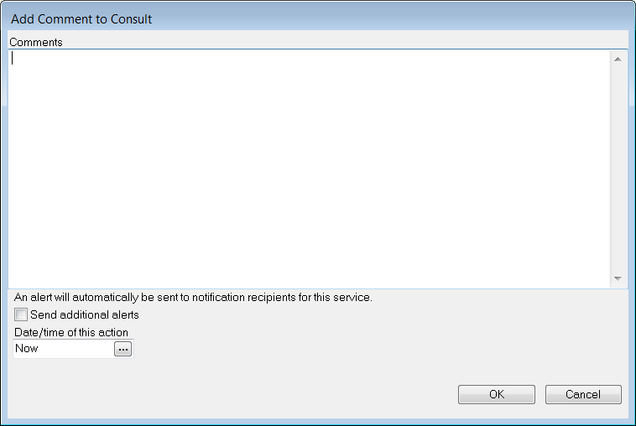

1. In the **Comments** field, right click to view the Consult Toolbox menu.

Figure 16: Consult Toolbox Menu

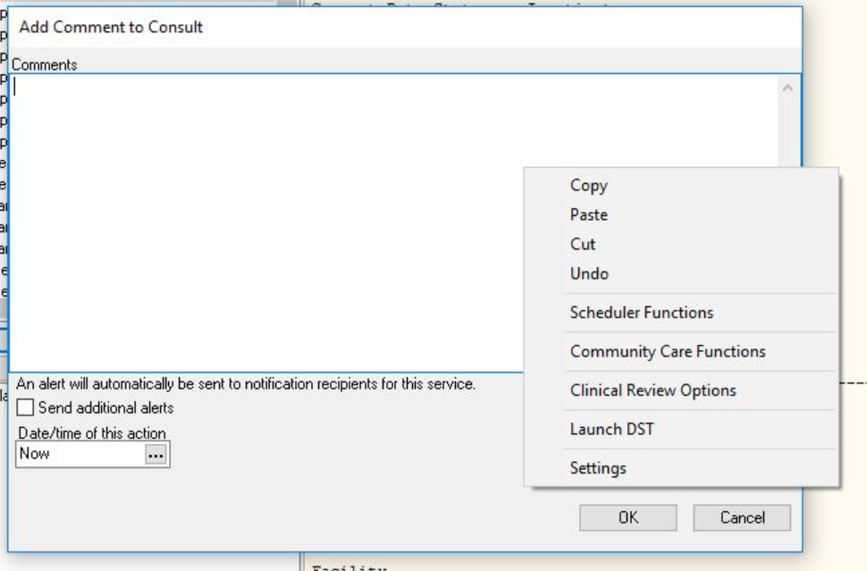

1. From the Consult Toolbox menu, select **Launch DST**. The **VA Single Sign-On** page displays.

Figure 17: VA Single Sign-On



1. Click **Sign In with VA PIV Card**. The **Select a Certificate** dialog box displays.

Figure 18: Select a Certificate



1. Select a certificate to authenticate yourself and click **OK**. The **ActivClient** dialog box displays.

Figure 19: ActivClient Login



1. Enter your PIN and click **OK**. The DST Dashboard displays.

Figure 20: DST Dashboard Screen



## Capturing Provider and Veteran Decision Data

DST allows you to enter additional information required to fully document the decision to order a VA consult or create a Community Care referral. To enter additional information, follow the steps listed below:

1. Under the **Consult** section, enter/update the **Urgency**. If **Special Instructions** is selected, you will need to enter/update the **No Later Than Date** field.
2. Under the **Consult** section, enter/update the **CID/No Earlier Than Date** field.
3. If there are no other Community Care eligibility factors found, under the **Community Care** section, select an option from the **Best Medical Interest of Veteran** drop-down menu to establish eligibility. If **Other** is selected, you must enter information in the **Explanation** field.
4. If the Veteran is eligible for Community Care, from the **Veteran Community Care Choice** area, select the Veteran’s choice to TBD/defer, opt-in, or opt-out of Community Care.
5. If the Veteran is eligible for Community Care and opts-in, from the **SEOC** drop-down menu, select a SEOC to define the authorized care should the consult be forwarded to Community Care. The list of SEOCs is filtered based on the Clinical Service (based on government-furnished mapping) of the consult to eliminate unrelated SEOCs from the selection list. The SEOC content can be previewed after selection.
6. DST generates a standard Community Care Consult Name based on the SEOC selected.
7. From the **Consult Decision**, select **VA** to refer the consult to the VA or select **Community Care** if the Veteran opts-in for Community Care.
8. Once the required DST information is populated the save button will enabled. Click **Save**, the **DST Save Success Message** displays. The information captured on the DST dashboard will now be saved to the consult and available to be linked to the consult and displayed in the request for care section.

Figure 21: DST Save Success Message

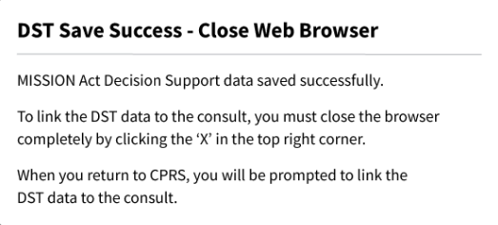

If DST is unable to save due to content missing, the **Unable to Save Mes**sage displays. Update the missing fields and save again.

Figure 22: Unable to Save Message

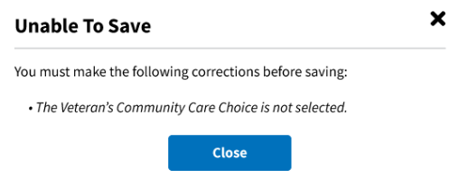

If something went wrong while trying to save, the DST Save Failed Error Message displays.

Figure 23: DST Save Failed Error Message

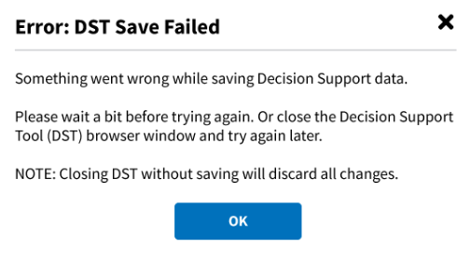

1. To link the DST data to the consult, close the browser completely by clicking the **X** in the top right corner. The **Link DST Data** message displays.

Figure 24: Link DST Data

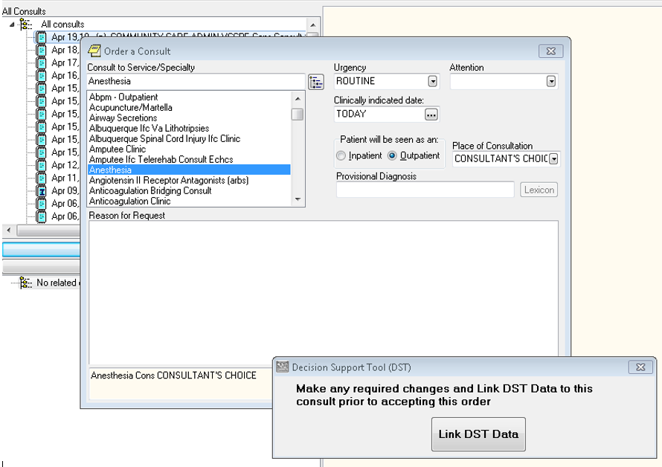

1. Click **Link DST Data**. Once the consult is accepted a DST ID number is used to capture the information gathered in the DST dashboard. Once the consult is signed, the actual information itself is displayed in the **Reason for Request** section of the consult using standard 3-digit codes and descriptions.

Figure 25: DST Data

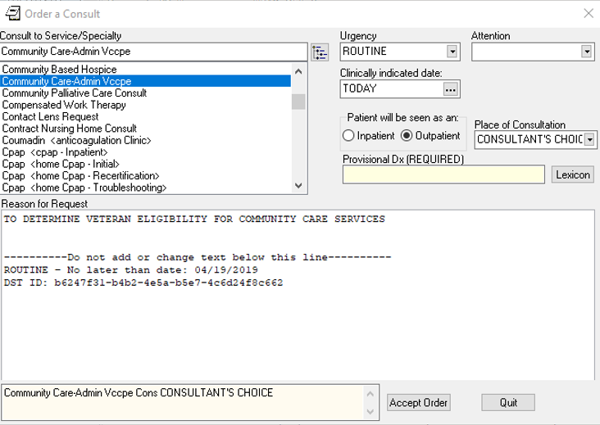

1. Click **Accept Order**. The consult is signed and actual DST information is displayed in the form of a comment. Any changes to the DST after a consult is signed will result in a new comment.

Figure 26: DST Data Displayed in Consult Details

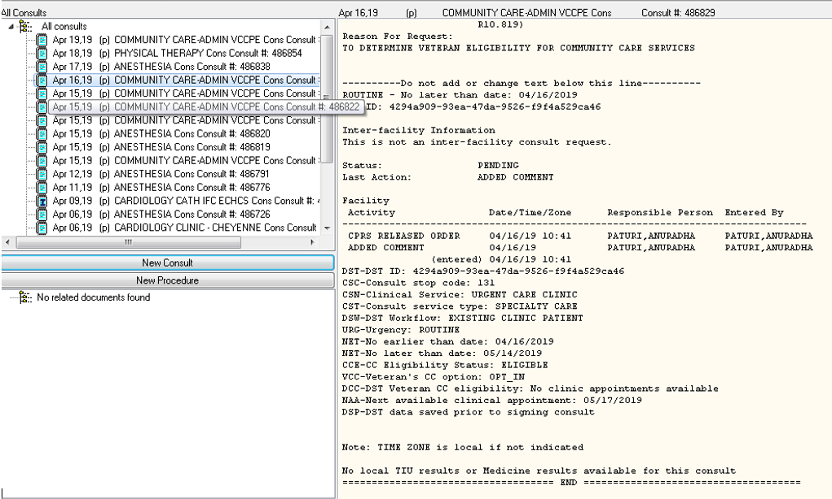

# Troubleshooting

## Unable to Lookup Clinical Service

Concurrent to the remote data calls, DST searches an internal table (updated nightly from CDW) to get the Clinical Service for the selected consult and sets the consult type to Primary Care/Mental Health (PC/MH) or Specialty Care (SC) based on government-provided mapping data. If the Clinical Service cannot be identified from the CDW tables, a message will be displayed in the VA facilities area to prompt the user to select the Clinical Service manually.

Figure 27: Manual selection of Clinical Service

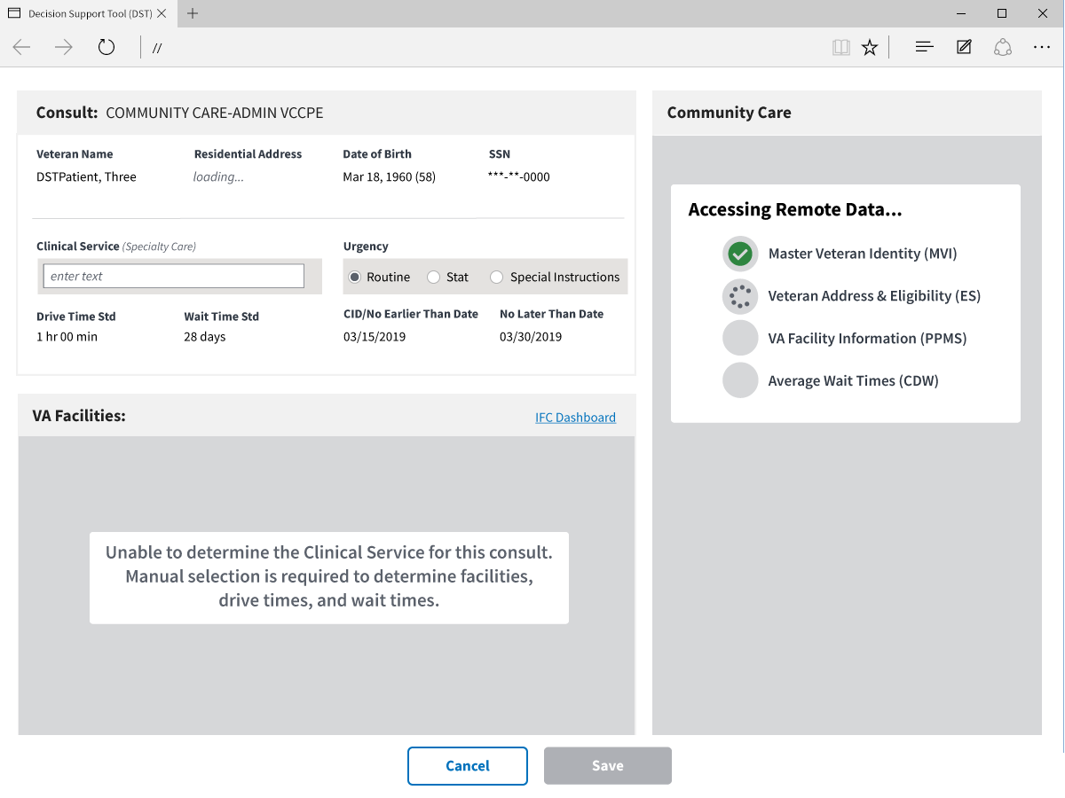

## MVI Error Handling

If MVI does not respond within 10 seconds or a single exact match ICN is not returned, an error message is displayed to the user, the error code is logged in the DST database, the rest of the remote data calls are skipped, and the user can continue with the DST workflow. The specific error code will be stored in the DST database and added to comments after consult is signed to support analytics/reporting.

Figure 28: Veteran Identity Error Handling

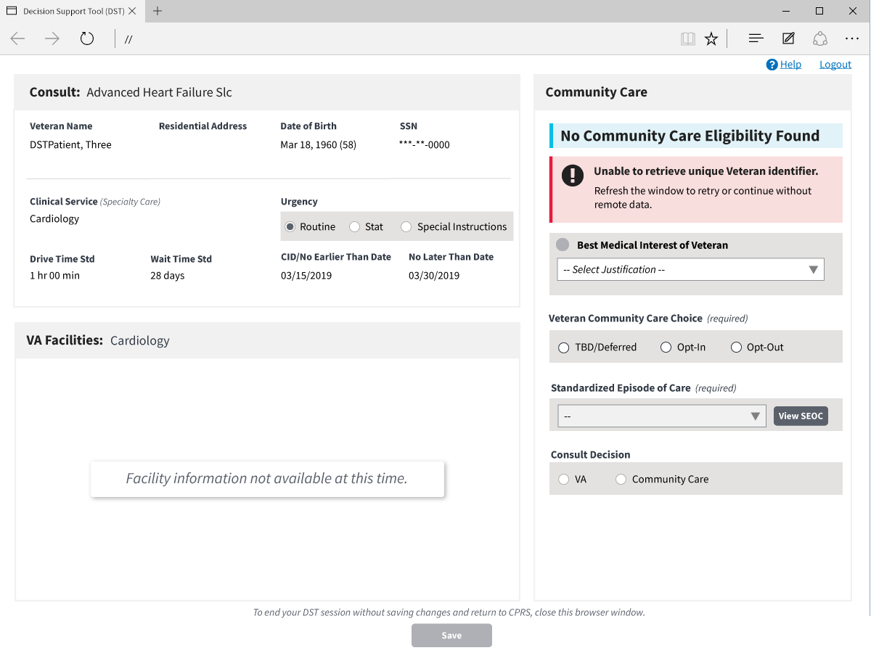

## ES Error Handling

If ES does not respond within 10 seconds or the Veteran ICN is not found, an error message is displayed to the user, the error code is logged in the DST database, the rest of the remote data calls are skipped, and the user can continue with the DST workflow. The specific error code will be stored in the DST database and added to comments after consult is signed to support analytics/reporting.

Figure 29: Veteran Eligibility Error Handling

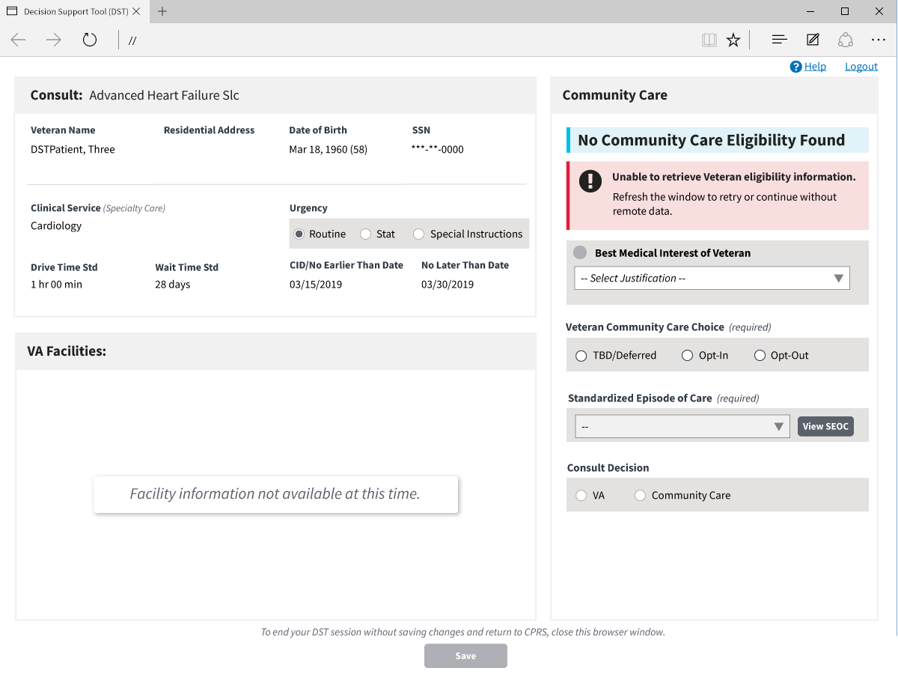

## PPMS Error Handling

If PPMS does not respond within 10 seconds an error message is displayed to the user in the VA Facilities section, the error code is logged in the DST database, Drive Time and Wait Time VCEs displayed with error icons, and the user can continue with the DST workflow. The specific error code will be stored in the DST database and added to comments after consult is signed to support analytics/reporting.

Figure 30: VA Facilities Error Handling

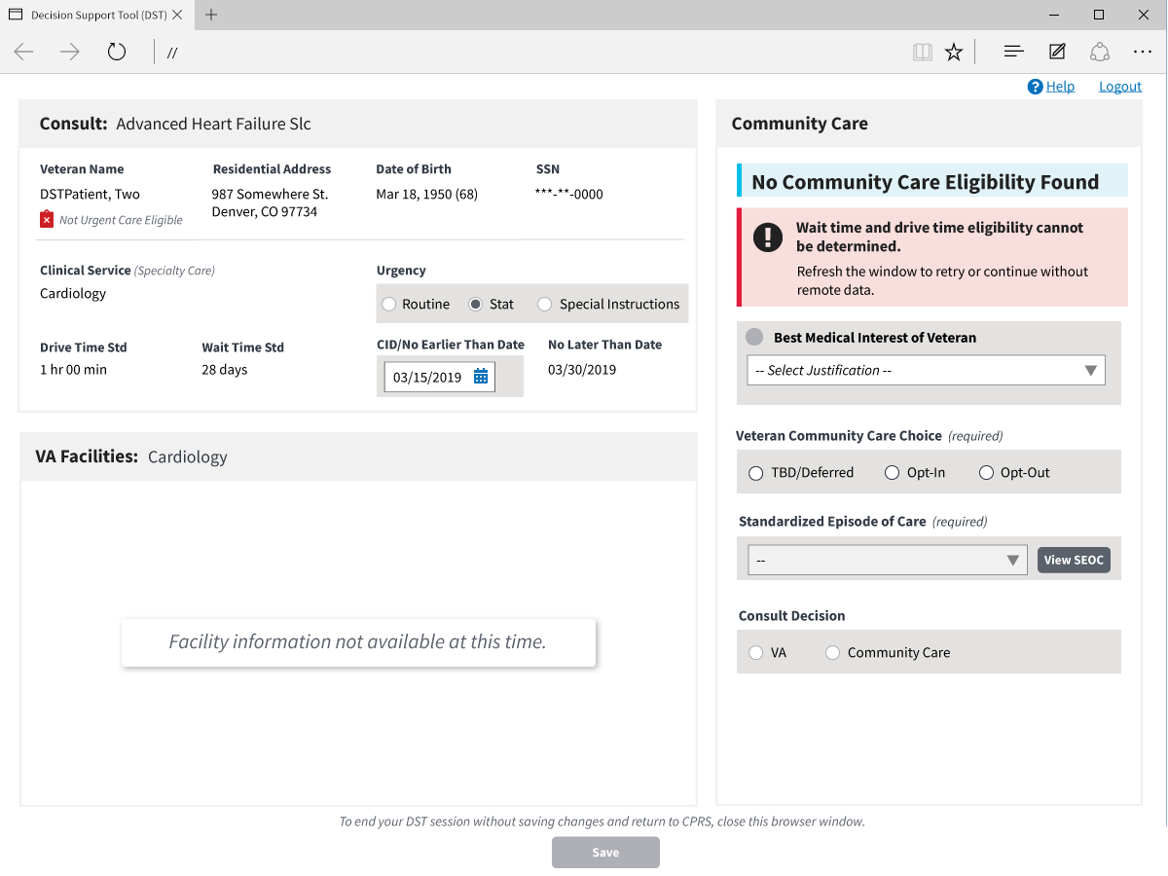

# Acronyms and Abbreviations

Table 2. Acronyms and Abbreviations

|  |  |
| --- | --- |
| Acronym | Definition |
| CD2 | Critical Decision Point #2 |
| CPRS | Computerized Patient Record System |
| DST | Decision Support Tool |
| EMR | Electronic Medical Record |
| FOIA | Freedom of Information Act |
| FQDN | Fully Qualified Domain Name |
| ID | Identification |
| IFC | Inter-Facility Consults |
| IP | Internet Protocol |
| IT | Information Technology |
| OI&T | Office of Information and Technology |
| OMB | Office of Management and Budget |
| OSEHRA | Open Source Electronic Health Record Agent |
| P&LMS | Pathology and Laboratory Medicine Service |
| PII | Personally Identifiable Information |
| SEOC | Standardized Episodes of Care |
| URL | Uniform Resource Locator |
| VA | Department of Veterans Affairs |
| VCCP | Veteran Community Care Program |
| VDL | VA Software Document Library |
| VHA | Veterans Health Administration |
| VIP | Veteran-focused Integrated Process |